CO₂ hydrogenation to CH₄

Responsible for the course: Oliver Kröcher (oliver.kroecher@psi.ch), phone: 056 310 20 66
Responsible for the experiment: Bingqiao Xie (bingqiao.xie@epfl.ch), phone: 076 289 25 60

- Objectives
- To familiarize with a plug flow catalytic reactor together with analytic gas analyser (FTIR) for gas phase reactions at elevated temperatures.
- To be able to summarize and analyze catalytic testing data in the form of tables and graphs.
- To study the catalytic conversion, product yield and product selectivity of the reaction as a function of temperature over heterogeneous catalysts.
- Background
In recent years, many solutions have been proposed to reduce the carbon dioxide footprint of industry, transportation, and energy conversion. Considerable attention has been focused on carbon dioxide storage by exploiting new solutions for carbon capture but also the transformation of carbon dioxide to renewable fuels such as methanol, liquid hydrocarbons, and methane [1]. Besides being the main component of natural gas, methane can be produced by microbiological processes as well as by thermochemical routes using heterogeneous catalysis.
The anaerobic digestion of biomass produces biogas, which consists of methane and significant amounts of carbon dioxide. Hence, the implementation of a downstream process that converts the undesired carbon dioxide to additional methane is desirable. In this context, the catalytic hydrogenation of carbon dioxide to methane has been widely studied, which is known as the Sabatier reaction (eq. 1). It is thermodynamically favorable but has significant kinetic limitations since the reduction of the fully oxidized carbon to methane is an eight-electron transfer process [1]. Hence, the reaction requires a catalyst to achieve acceptable rates and selectivities.

CO₂ + 4H₂ → CH₄ + 2H₂O ΔH°₂₉₈= -165.12 kJ/mol (Eq. 1)

Depending on the catalyst used and the reaction conditions, carbon monoxide can also be formed via the reverse water gas shift reaction (eq. 2). Carbon monoxide can then be further reduced by hydrogen to produce methane (eq. 3) [2].

CO₂ + H₂ → CO + H₂O ΔH°₂₉₈= +41.16 kJ/mol (Eq. 2)
CO + 3H₂ → CH₄ + H₂O ΔH°₂₉₈= -206.28 kJ/mol (Eq. 3)
A wide range of catalysts has been investigated to improve both reaction rate and selectivity. The main metals studied are the group VIII metals (e.g., Ru, Rh, Ni) and other noble metals (e.g., Pd, Pt) [1]. Catalyst degradation at high temperatures mainly through sintering and the limited catalyst stability over time due to the presence of poisoning species such as sulfur in the reaction gas feed are the major challenges. Hence, scientists aim at minimizing these limitations by the appropriate choice of the catalyst type (active metal, oxide supports, metal loadings, etc.)

- Methods and materials

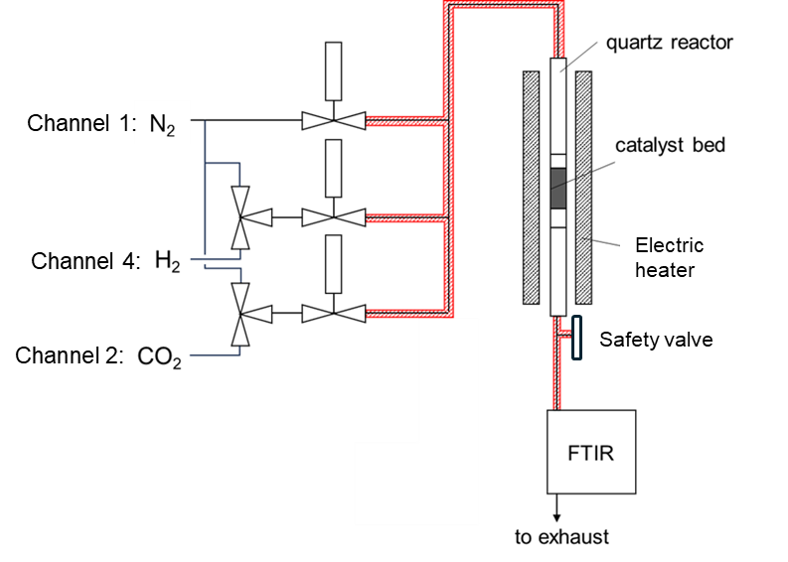
Figure 1. Scheme of the CO₂ hydrogenation setup.

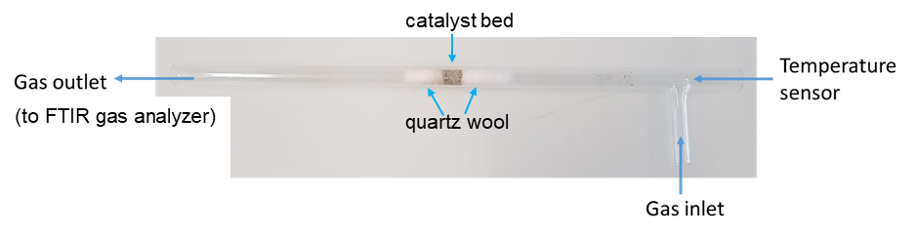
Figure 2. Plug flow reactor to study catalysts in powder form.
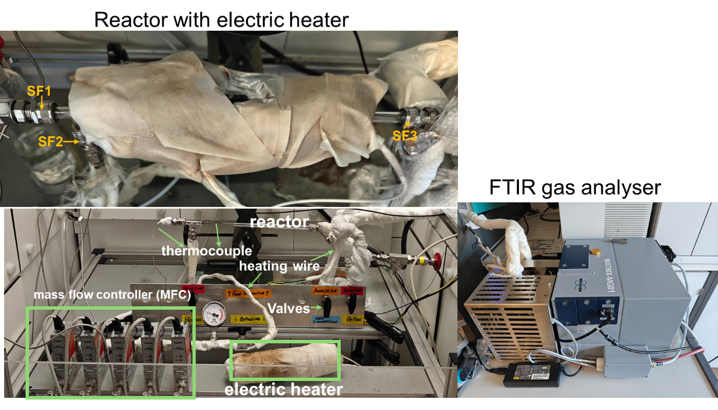
Figure 3. CO₂ hydrogenation setup. SF refers to Swagelok fitting.

The catalyst bed is positioned in a quartz reactor (Figure 2) heated by electric wire (Figure 3). A thermocouple (temperature sensor) is placed in the reactor and the sensor tip is inserted in the catalyst bed. This allows us to record the catalyst temperature throughout the experiment. Mass flow controllers (MFCs) together with a LabVIEW interface are used to control the gas flow rates and prepare gas blends. The entire gasline downstream of the MFCs (until the FTIR) is heated to avoid water condensation in the gas lines and the reactor. The lines are heated using heating wires and are then isolated using insulation bands (Figure 3). Finally, the composition of the reactor exhaust is analyzed by a Fourier transform infrared spectrometer (FTIR, Figure 1).

4. Experimental procedure
- You will analyze a commercial 5Ni/Al₂O₃ catalyst (with 5wt.% loading of Ni).
- Load the catalyst in the reactor (50 mg + 0.2 g of silica beads for dilution, both provided) between two layers of quartz wool.
Aim: Silica beads are inert for the reaction but used to obtain an even dispersion of the catalyst and to avoid temperature hot spots.
- Connect Swagelok fitting (SF1) nut and insert the thermocouple into catalyst bed, tighten Swagelok fitting SF1, connect SF2 and insert reactor into heater, then connect SF3. Slowly tighten SF2 and SF3 when all ports are positioned properly. Finger-tight is required only and leakage test will be conducted to ensure system is tight. (The assistant will demonstrate and assist students during this step).
- Prepare a reduction feed containing 12 mL/min H₂ (setup value in LabView software: 10.5, Channel 4) and 62.5 mL/min N₂ (setup value: 30, Channel 1). Change the setpoint values in the LabView software.
- Pre-reduce the catalyst: Heat the reactor to 600°C (20°C/min) and leave it at this temperature for 30 min.
Aim: to remove surface impurities and activate the catalyst.
- Fill liquid N₂ into the FTIR analyzer. After 5-10 minutes, open the OPUS-GA software.
The FTIR analyzer uses a Mercury-Cadmium-Telluride (MCT) detector, which is extremely IT sensitive when cooled to very low temperatures.
- Record a background spectrum and start the IR measurement in OPUS-GA software.
- Decrease N₂ flow to 62.5 mL/min (setpoint: 30, channel 1), add 24 mL/min H₂ (setpoint: 20.8, channel 4), and finally 6 mL/min CO₂ (setpoint: 10, channel 2). The total flow for the experiment is 92.5 mL/min.
- Test the catalytic activity as a function of the reaction temperature (400°C, 375, 350, 325, 300 °C, respectively:
- Dwell at each temperature for 10-20 min when reaction reaches equilibrium (stabilized signal in OPUS-GA software).
- After the test at 300°C, switch to 37 mL/min N₂ (setpoint: 18, channel 1) and set the reactor temperature to 25°C.
5. Time management (real situation could vary)
13:00-13:20 pre-experiment introduction and questions & task distribution
13:20-13:40 catalyst loading, reactor installation, leak test/flow check
13:40-14:30 catalyst reduction under N₂/H₂ flow (break time: 13:40-14:00)
14:30-14:50 data recording and setting flows for reaction
14:50-16:50 temperature ramping and data collection (break time: 14:50-15:10)
16:50-17:00 reaction finish, system cooling, necessary cleanup/tidy up.

6. Report
- CO₂, CO, CH₄ concentration ($n$) can be measured by Online FTIR (mixing ratios (MR)). This data recorded for 5Ni/Al₂O₃ during the experiment will be sent (together with the activity data of 5Ru/Al₂O₃) to you afterwards.
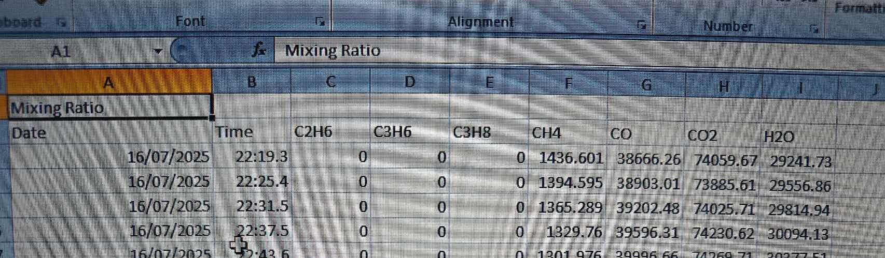
Figure 4. Example of data opened in Excel Worksheet (with time and mixing ratios of CO, CO₂, CH₄ (ignore others))
- Plot the CO₂ conversion (%, X), CH₄ selectivity (%, S_{CH4}), CO selectivity (%, S_{CO}), CH₄ yield (%, Y) as a function of temperature that you determine using the following equations:
$$X_{{CO}_{2 }}\left(\%\right)= \frac{n_{{co}_{2}}^{in}-n_{{co}_{2}}^{out}}{n_{{co}_{2}}^{in}} ×100$$
$$S_{CH4}\left(\%\right)=\frac{n_{CH4}^{out}}{n_{co}^{out}+n_{{CH}_{4}}^{out}}×100$$
$$Y_{CH4}\left[\text{\%}\right]\text{=}\frac{n_{CH4}^{out}}{n_{co2}^{in}}×100$$
- Discuss the results; describe and explain what you observe in the graph.
- Calculate the apparent activation energy barrier (E_{a}) using the Arrhenius plot.
- How would you explain the difference in activity observed between the two catalysts (5Ru/Al₂O₃ and 5Ni/Al₂O₃).

7. References
[1] W. Wang, J. Gong, Methanation of carbon dioxide: an overview, Front. Chem. Sci. Eng. 5 (2011) 2.
[2] G. Garbarino, P. Riani, L. Magistri, G. Busca, A study of the methanation of carbon dioxide on Ni/Al₂O₃ catalysts at atmospheric pressure, Int. J. Hydr. En. 39 (2014) 11557.

